Business Requirements

INSURANCE RISK & CLAIMS ANALYSIS
BUSINESS REQUIREMENT
An insurance company is looking to better understand its policyholder base and claim patterns to make data-driven business decisions. Currently, policy and claims data are scattered across multiple sources, making it difficult for stakeholders to track performance and identify trends.
The company requires a centralized interactive dashboard in Power BI that can provide a clear overview of:

KPI’s Requirements:
- Total Policies – to measure the size of the active customer base.
Output:
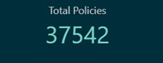
- Total Claim Amount – to track the overall financial impact of claims.
Output:
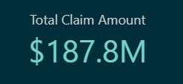
- Claim Frequency – to analyse how often claims are being made.
- Average Claim Amount – to assess claim severity and potential risk exposure.
Output:
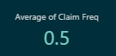
- Gender-wise Total Policies – to understand customer distribution across genders for better segmentation and policy targeting.
Output:
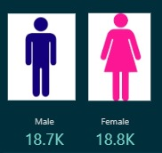

Chart’s Requirements:
To deep dive into the data, we need to go beyond KPIs and analyse different aspects of insurance policies and claims. Charts help us visually explore patterns, relationships, and anomalies across customer demographics, car details, and claim behaviours. By analysing charts, stakeholders can identify risk factors, understand customer segments, and optimize policy decisions.
For this report, all visualizations are designed around two key dynamic measures:
- Total Claim Amount
- Total Policies
These measures provide the foundation to compare, filter, and segment the data effectively.

Visualization Requirements:
- By Car Use (Donut Chart) – To analyse policy distribution and claim amounts based on how cars are being used (e.g., personal, commercial).
Output:
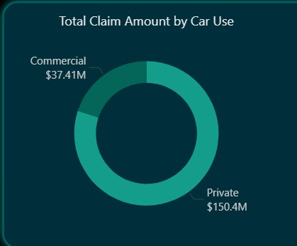
- By Car Make (Bar Chart) – To identify which car brands have higher policies and claims, highlighting brand-based risks.
Output:
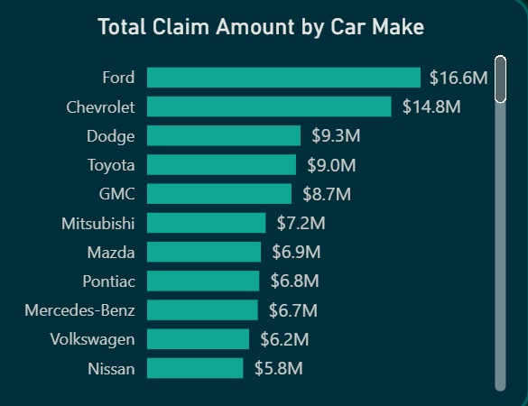
- By Coverage Zone (Donut Chart) – To evaluate policies and claims by geographic zones, useful for regional risk analysis.
Output:
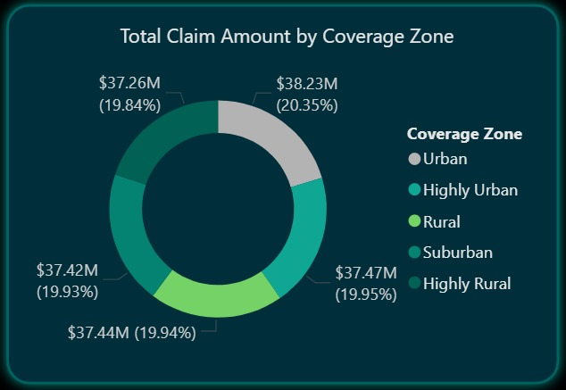
- By Age Group (Frequency Chart/Histogram) – To assess policyholders’ age distribution and identify which age brackets file more claims.
Output:
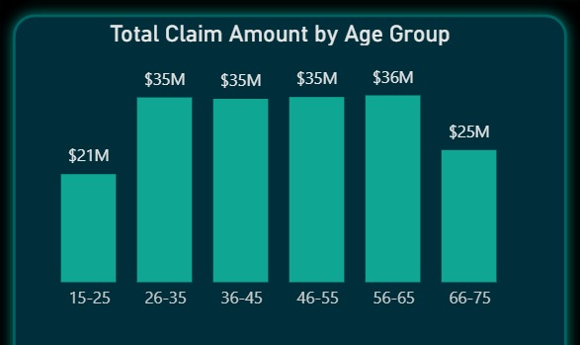
- By Car Year (Area Chart) – To analyse how the car’s age (year of manufacture) impacts policy counts and claim amounts.
Output:
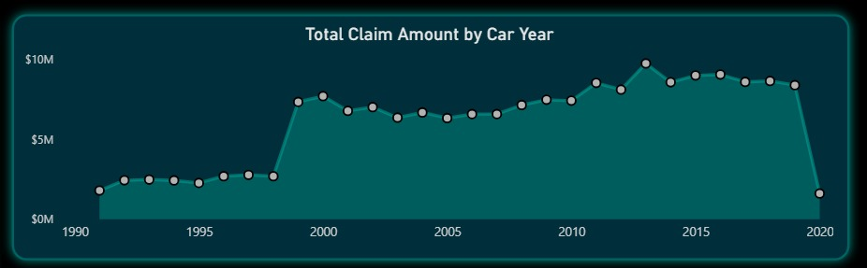
- By Kids Driving (Ribbon Chart) – To compare the impact of young drivers in households on policy count and claim amounts.
Output:
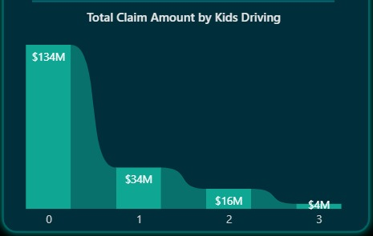
- By Education (Pie Chart) – To understand how education levels correlate with insurance policy adoption and claims.
Output:
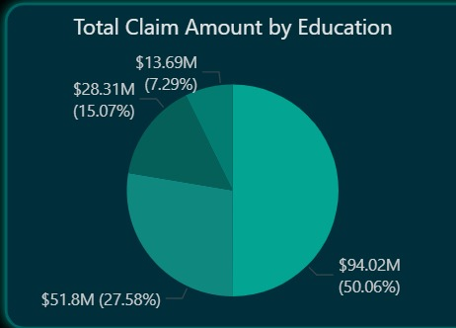
- By Education & Marital Status (Matrix Heat Grid) – To explore the combined effect of education and marital status on policies and claims, highlighting customer profiles.
Output:
